1. there are 4 semi-circles (with same colors) that each connect four circles.1 to 16 must be entered in the circles in such a way that the sum of the circles on each of the 4 curves is 34.

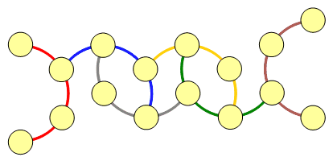

**Answer**: There are different solutions:

2

16 3 9 /

\ / | \ / | \ 5

13 | 8 | 11 |

| 14 | 7 | 12

4 \ | / \ | / \

/ 10 6 15

1

___________________________________

5

9 3 15 /

\ / | \ / | \ 7

13 | 2 | 11 |

| 14 | 1 | 12

8 \ | / \ | / \

/ 16 6 10

4

______________________________________